Day in the Life of the Hudson River 10/13/22
Donahue Memorial Park, Cornwall Landing, NY
RIVER MILE: 57
Salt Front: ~ RM 76
Trailside Museums & Zoo @ Bear Mountain State Park- Christopher O’Sullivan,
Willow Ave. Elementary School Christine Cleeves (4th grade)
Tom Lake, DEC HREP
50 students & 20 adults
Latitude 41° 26’36’’ N & Longitude –74°0’1’’W
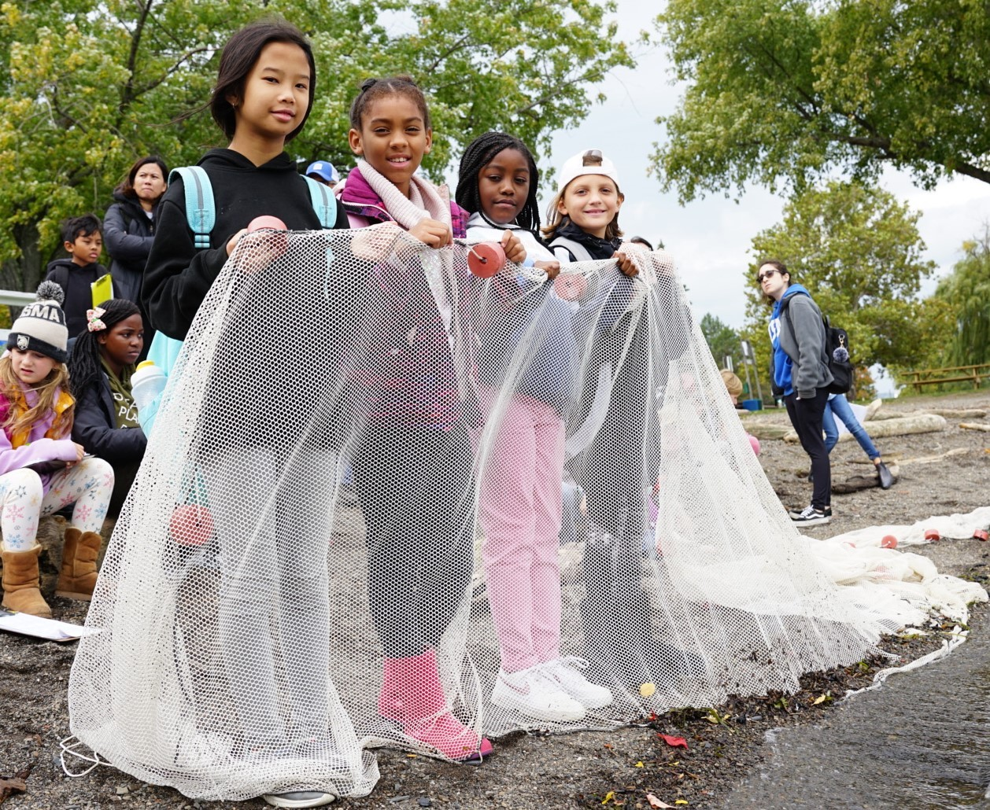 | 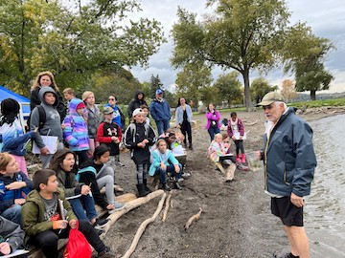

Location: Donahue Memorial Park, Cornwall Landing, NY
Area: Sandy beach used for seining and chemical samples. Sampling site near small dock used for turbidity.
Surrounding Land Use: 80% Open & Grassy, 15% Forested, 5 % Beach
Sampling Site: Pier, grassy, beach, altered banks, RipRap, wood bulkhead
Shoreline: NR
Water: Choppy
Plants in area: No plants in the water
River Bottom: Muddy & Rocky
*NR = Not read/recorded
ITEM |  | Time |  | Reading |  |  |  | Comments
Physical
Air Temperature |  | 10:12 AM  10:27 AM  10:43 AM |  | 17.78 ° C  19.44° C  22.22° C |  |  | 64°F  67°F  72°F
Wind Speed: |  | 10:49 AM |  | Anemometer  13-18 mph |  |  | Beaufort  4 | Direction  NW
Weather today |  | 10:30AM |  | > 75% cloud cover |  |  | No Rain
Weather the past 3 days: |  | No rain, warm and sunny
Tides- |  | Time |  | Rising, Falling, Unchanged |  |  | Water Height (cm)
 |  | 9:08 AM-9:45 AM |  | Rising |  |  | 22 cm  35 cm
Current- |  | Time |  | Cm/sec |  | Knots | North/South | Ebb/Flood/Still
 |  | 9:45 AM |  | NR |  | NR | NR | Flood
Water Temperature- |  | 10:38 AM |  | 18°C |  |  | 64°F
Turbidity- Long Sight Tube (120 cm) |  | 10:10 AM 10:21 AM |  | 24.1 cm  14.3 cm
Chemical
Salinity- HR Quantabs |  | 10:12 AM  10:21 AM  10:38 AM |  | 970 ppm Cl-  970 ppm Cl-  1048 ppm Cl- |  |  | 1752 ppm total sal  1752 ppm total sal  1,893 ppm total sal
Standardized Salinity – HR Quantab |  | NR |  |  |  |  | 1,956 ppm total sal
DO – NR |  | Time |  | Temp |  |  | ppm DO | % saturation
pH – Color Match Kit |  | 10:39 AM |  | 8
Nitrates- NR
Phosphates- NR
Alkalinity- NR
Biological
Fish – Seine |  | Number |  | Name |  |  | Length of longest | Length of smallest
11:10 AM -12:00 PM |  | 87  1  3  8  1  12  3 |  | Blueback Herring  American Shad  Spottail Shiner  Atlantic Silverside  White Perch  Striped Bass  Largemouth Bass |  |  | 6.7 cm  8.9 cm  7.4 cm  9 cm  4.5 cm  8.2 cm  16.6 cm
Fish Totals |  | TOTAL: 115 |  | Diversity: 7
Macroinvertebrates |  | Number |  | Name |  |  | Length of longest | Length of smallest
 |  | 1 |  | Blue Crab |  |  | 6 cm
Macroinvertebrate Totals |  | TOTAL: 1 |  | Diversity: 1
Sediment Core - NA
Length | H2S smell |  | Oxid Top |  | Oil |  | Grain Size | Other Features
Boats-NR
 | Time |  | Name |  | Color |  | North/Southbound | Light/Loaded
Commercial
Residential

